CMPE314 – SOFTWARE ENGINEERING
Lab 1 Solution: Collaborative Project Setup and Gantt Charting
Project: FitTrack – Personal Fitness Companion
Group 3/1: Tawfig Malik (22115813), Lahsen Aittjiou (22118897), Hassan Eihab HassanAli (22211935)

Part 1 – GitHub Pages setup
Use the existing FitTrack repository. Enable GitHub Pages from Settings > Pages, branch main, root folder. Add all team members and the lab instructor as collaborators with Write access.

index.md file to upload
# Group 3/1 – FitTrack: Personal Fitness Companion
## Class Group
CMPE314 Software Engineering – Group 3/1
## Team Members
- Tawfig Malik – 22115813
- Lahsen Aittjiou – 22118897
- Hassan Eihab HassanAli – 22211935
## Project Description
FitTrack is a web-based personal fitness companion. It allows users to register/login, log workouts, log meals, set a calorie goal, and view weekly calories consumed vs burned using charts.

Part 2 – Sample Gantt chart
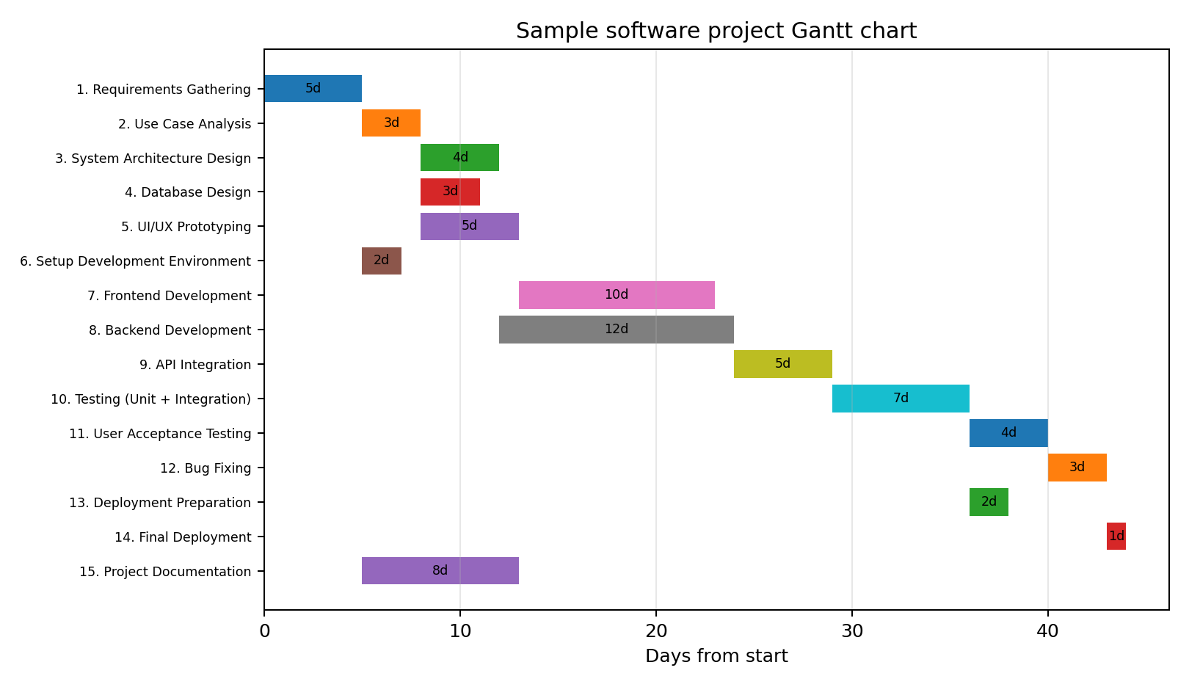
ID | Task | Duration | Predecessors
1 | Requirements Gathering | 5 | -
2 | Use Case Analysis | 3 | 1
3 | System Architecture Design | 4 | 2
4 | Database Design | 3 | 2
5 | UI/UX Prototyping | 5 | 2
6 | Setup Development Environment | 2 | 1
7 | Frontend Development | 10 | 5,6
8 | Backend Development | 12 | 3,4,6
9 | API Integration | 5 | 7,8
10 | Testing (Unit + Integration) | 7 | 9
11 | User Acceptance Testing | 4 | 10
12 | Bug Fixing | 3 | 11
13 | Deployment Preparation | 2 | 10
14 | Final Deployment | 1 | 12,13
15 | Project Documentation | 8 | 1
Submit the GitHub Pages URL after checking that the page is live.

